

**Introduction to Python: Week 1 Lab**

*Prepared by: Hackwagon*

**Learning Outcomes:**

* Declare variables, and manipulate the variables to perform arithmetic operations
* Make use of input function to solicit user inputs
* Know how to perform variable conversion
* Be conversant with the string slicing function of python
* Learn to concatenates string and other non-string variables
* Understand how to use special characters
* Debugging python programs

**Question 1: Uploading a Jupyter notebook**

By now, after undergoing the first class, you probably would have written at least a few lines of code on the jupyter notebook editor. Going forward, you will be writing your data analytics and visualizations codes on the notebook as well. However, have you wondered how would you share your codes and results with your team or colleagues? In this short question, we will learn how to download our jupyter notebook to share with other people, and how to deploy the notebook written by other people.

**How to download your work to share with other people:**

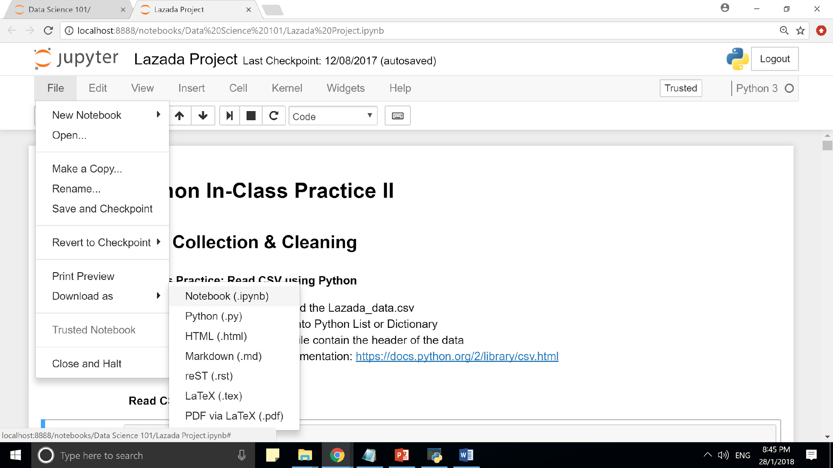

* On your editor, click on “File”, “Download as” and “Notebook (.ipynb)”, this will download your work in the jupyter notebook format, with the extension .ipynb
* To share your work with your friends, all you have to do is just send the folder to them, and get them to upload, and they will immediately be able to see your analysis

**How to upload someone else’s work:**

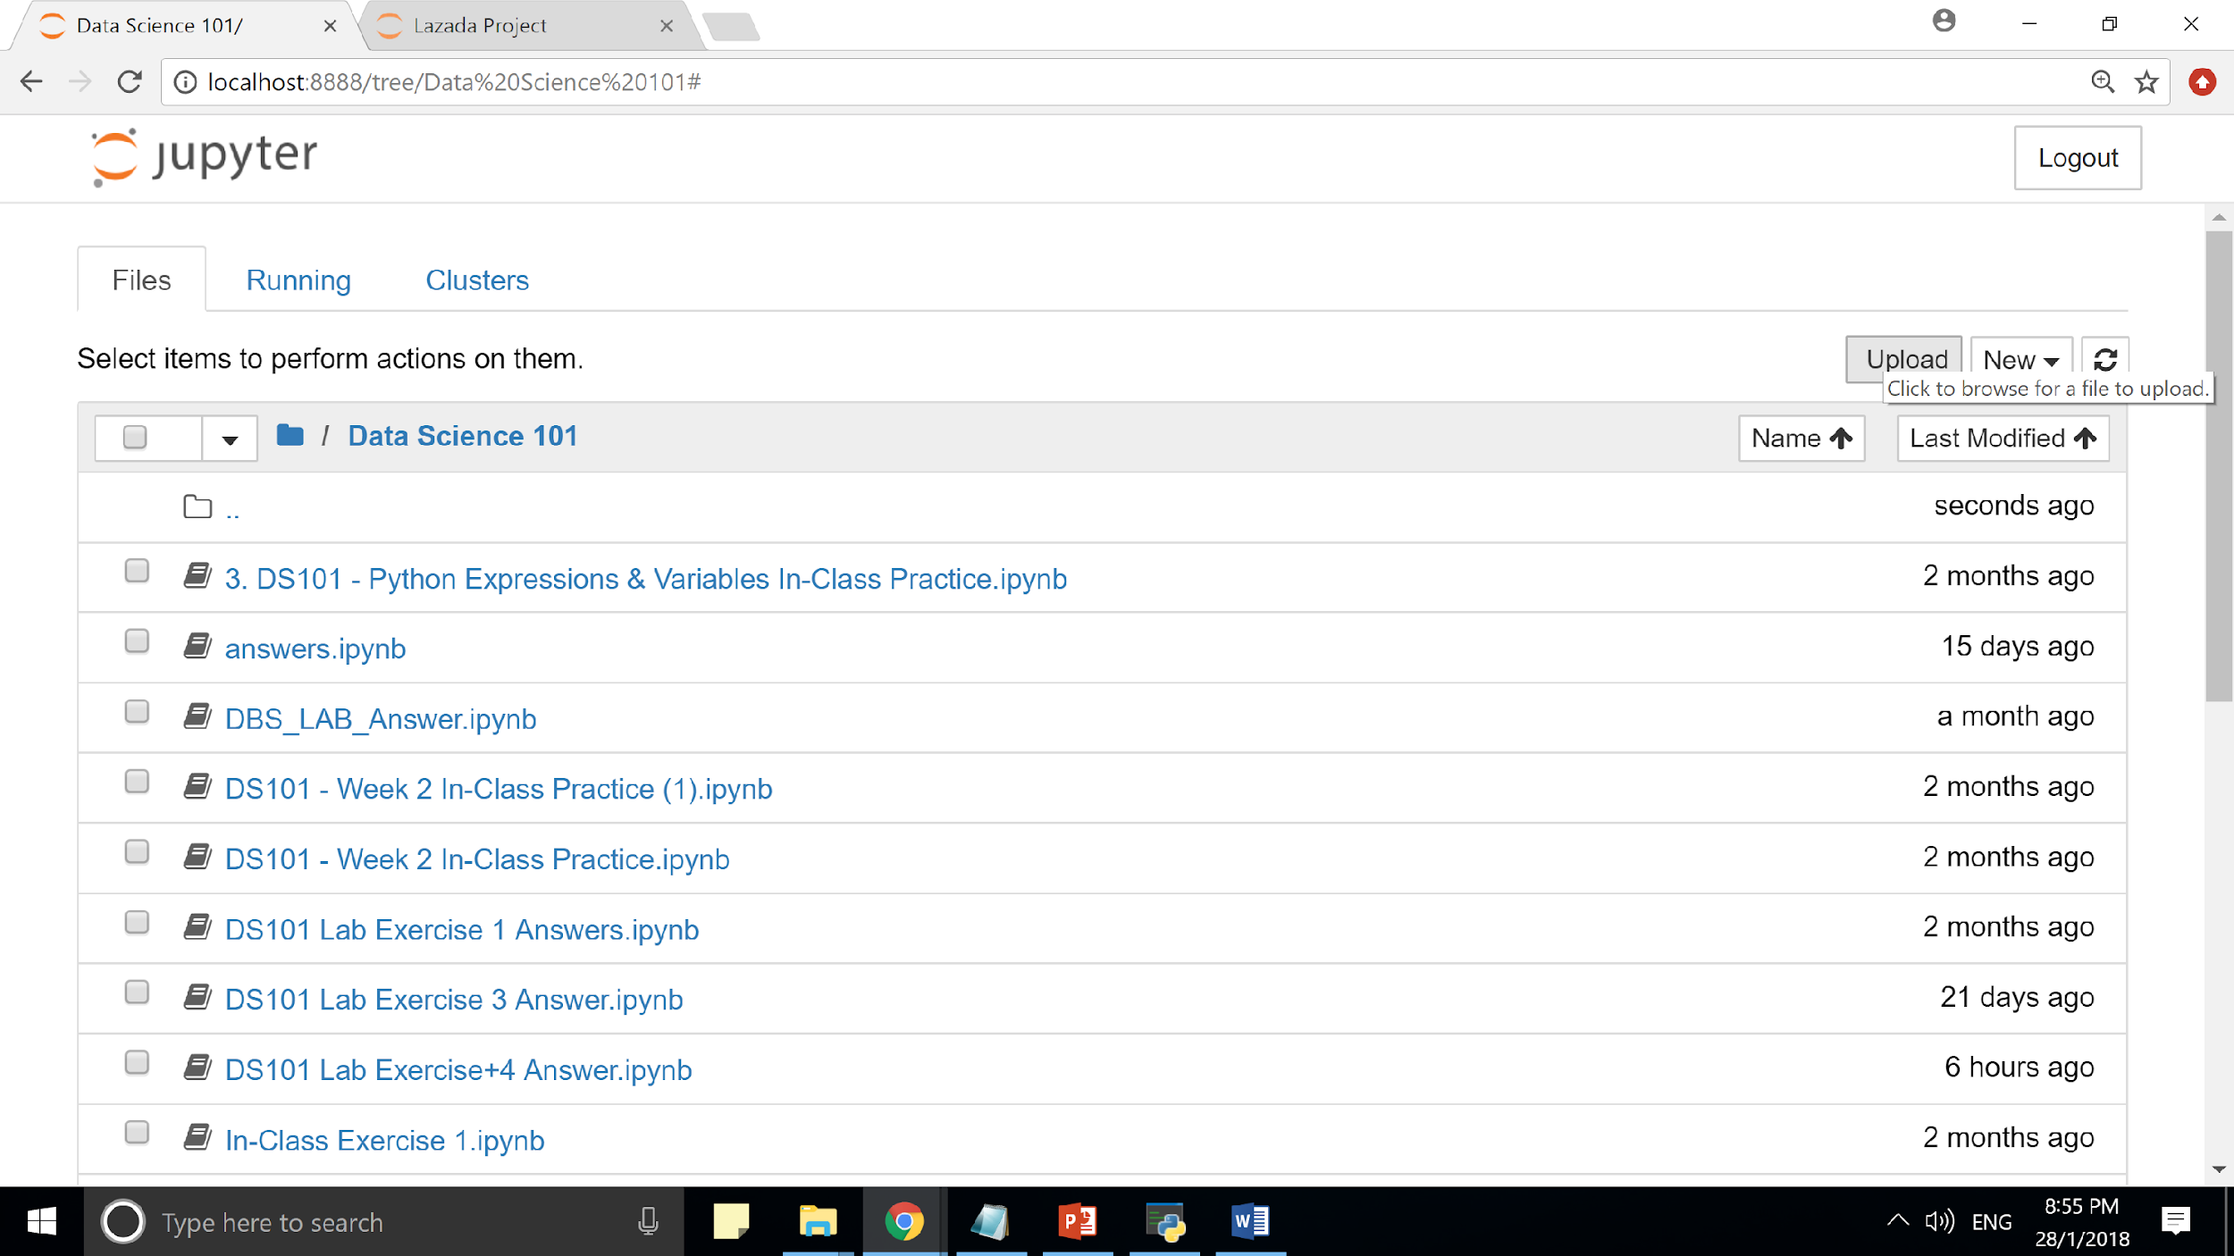

* Go to your jupyter notebook main directory (As shown above)
* Thereafter, click on the upload button

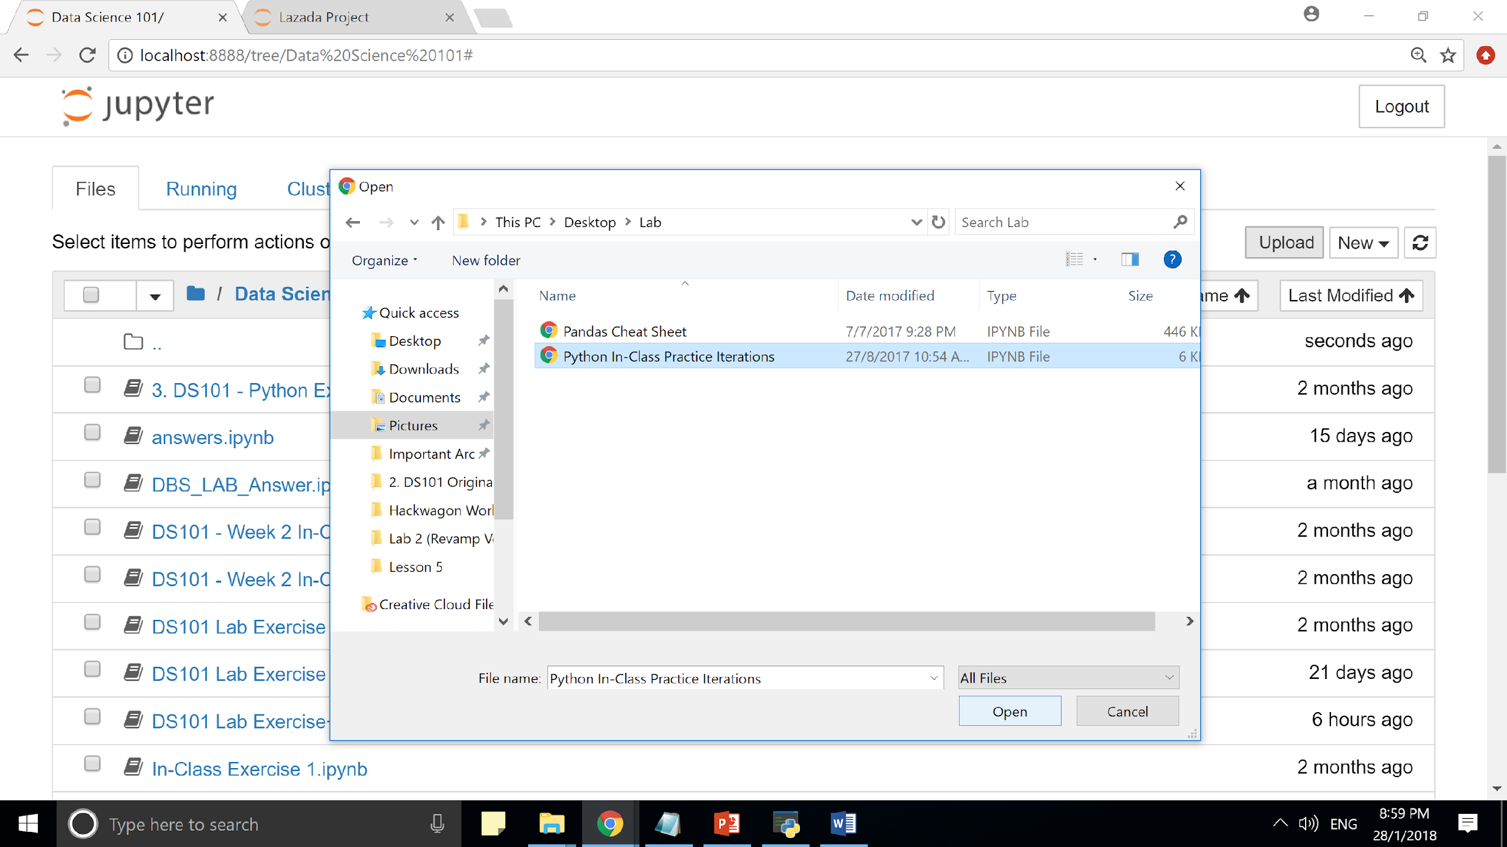

* Navigate to the jupyter notebook which you want to upload and upload it

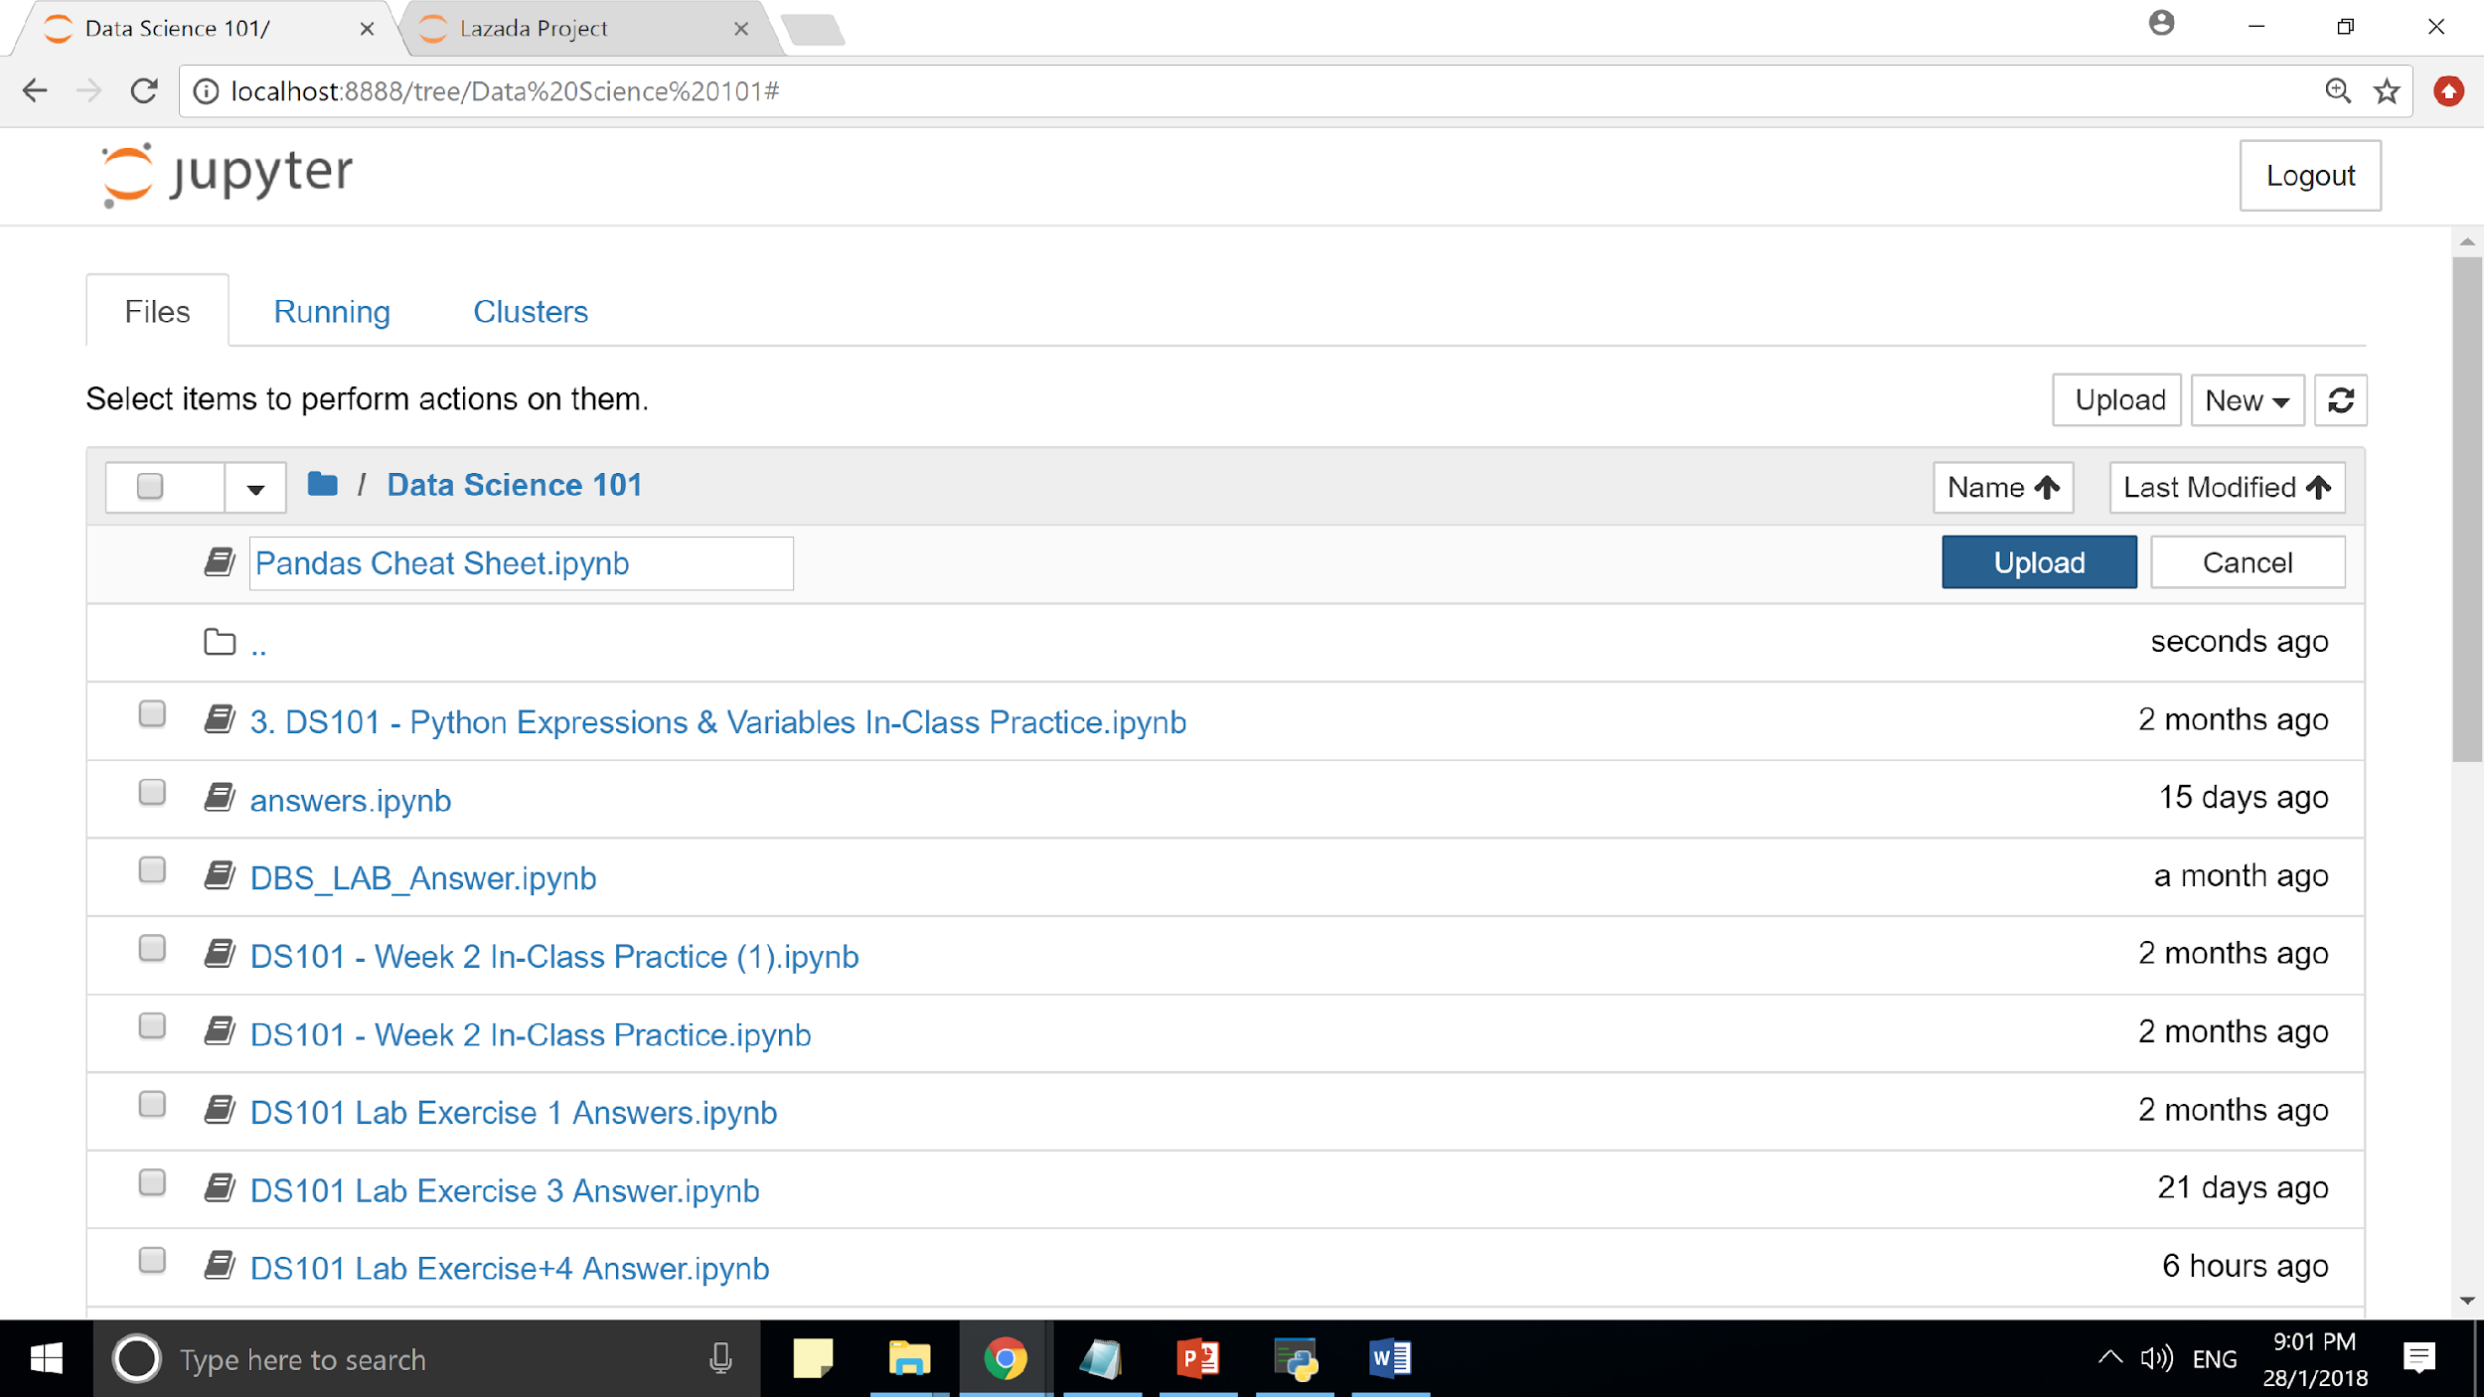

* You will see the above screen
* After that, you just need to click on the blue upload button to load the notebook
* To open the notebook, you just need to click on the notebook in the jupyter notebook directory above. A window with the jupyter notebook editor and codes will be opened. And there you have it, access to someone else’s codes.

**Question 2:**

Print the type of the following variables:

Channel_Title = “20th Century Fox”

Title = “Pirates of the Caribbean”

Likes = 23009

Comments = 2000

Rating = 4.7

Popular = True

**Question 3:**

Write the data type of the following variables in the table below:

|  |
| --- |
| **Variables** |
| Likes = ‘100’ |
| Likes = int(Likes) |
| Channel_Title = 1.7 |
| Channel = “Lord of the Rings” |

**Question 4:**

One of the typical metrics for measuring the engagement of videos is through likes per view. Given the following data, write a program to measure the likes/view of “Lord of the Rings”

Title = “Lord of the Rings”

Number_of_likes = “30”

Number_of_views = 30218

**Question 5:**

One of the title of the video contains some special characters. Make use of string indexing to remove it

Title = “Lord of the*&@#(* Ring”

Your output should be: “Lord of the Ring”

**Question 6:**

One of the title of the video is reversed. Make use of string indexing to reverse it back.

Title = “rettop yrrah”

Your output should be: “Harry Potter”

**Question 7:**

A newbie to programming wrote the following piece of code to calculate the engagement of a certain video. However, her codes were met with syntax, logic bugs and exceptions. Debug the following code for her:

|  |
| --- |
| Number of likes = ‘35000”  Number_of_views = 1000000  engagement = Number_of_likes / Number_Of_views  print(“The engagement rate is: ” + engagement) |

**Question 8:**

Another newbie to programming wrote the following piece of code to calculate the engagement of a video. However, her codes were met with syntax, logic bugs and exceptions. Debug the following code for her:

|  |
| --- |
| #Another way to calculate engagement is the number of comments per view  Num_of_comments = 2389  Num_of_views = 9233000  Engagement_lvl = Num_of_views / Num_of_comments  print(“The engagement rate is: ” + engagement) |

**Question 9:**

Watch the following short videos in preparation for the next lesson:

|  |  |  |
| --- | --- | --- |
| **Topics** | **Video Link** | **Duration** |
| String, Lists, Tuples, Dictionaries | <https://www.youtube.com/watch?v=19EfbO5D_8s> | 21min |
| Boolean Logic | <https://www.youtube.com/watch?v=mQrci1kAwh4> | 9 min |